**RAD**

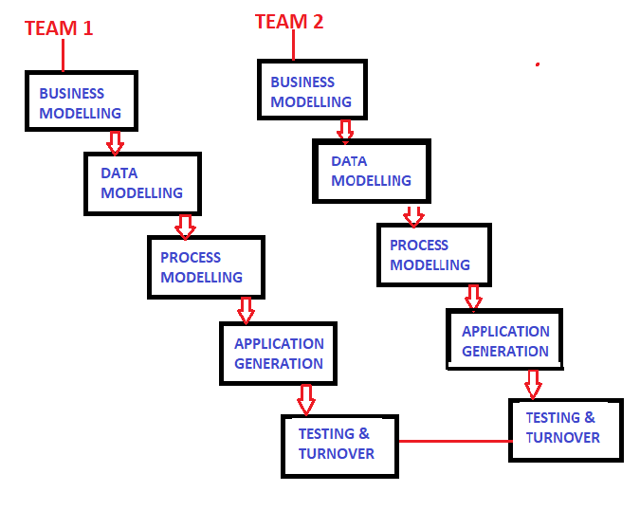

* **BUSINESS MODELING**

The information flow along the business function is defined by answering the questions

A complete business analysis is performed to find information for business

* **DATA MODELING**

The data collected from business is refined into set of objects/entities.

The attributes of all data sets are identified and defined.

The relationship between these data objects is established and defined in details

* **PROCESS MODELING**

The data object sets defined in the Data modeling phase are converted to establish the business information flow.

The process model for any changes or enhancements to data object sets is defined.

* **APPLICATION GENERATION**

The actual system is built.

Coding is done to convert process and data model into actual prototypes

* **TESTING & TURNOVER**

The prototypes are independently tested during iteration

Hence overall testing time is reduced in the RAD model

It reduces risk of major issues

Overall testing is performed for testing the integrated models